Jason Vaughan
527 Broadway #11
San Francisco, CA 94133
415-336-6116
jason@jasonvaughan.com

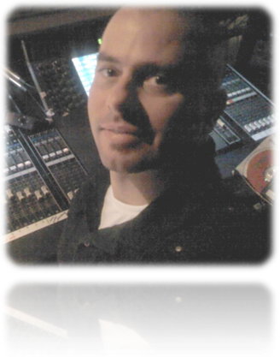
_{Objective:}
Seeking a full time production/management position with a busy event center or production company. I enjoy technical challenges and working with talented colleagues and state of the art equipment. My passion is learning new technologies and putting my skills to use.

Technical Education
Barco Screen Pro, Encore and FSN Certifications
San Francisco Recording Institute Graduate
Pro Tools 10 & 11 Professional Recording Expert
Barco, Level A Video Engineering Certficate
Many years of “on the job” training via IATSE Local 16, 50 and 134
Microsoft Windows Media Service Provider Certified
Citrix XEN Server Virtualization Certified
Citrix XEN Desktop Certified
Cisco Certified Network Design Associate Certified
Sun Workstation and Enterprise Certified
Certified Microsoft Office Trainer
College Math and Linux Classes
Designed and built a scalable internet server / render farm for 3D and After Effects Rendering
Designed a turnkey webcasting system in use by Government and Universities

Professional Experience
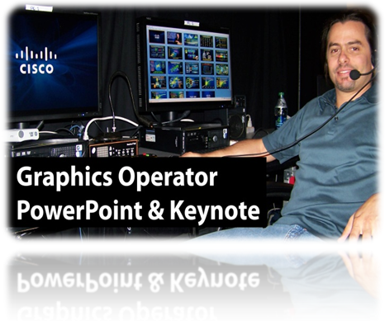
Freelance: Still / Motion Graphics Designer, Digital Signage / IT Manager and Producer

June 1998 – Present
MISC Production, AV Companies, Corporations & Orgs

I freelance for various production companies including; ETS, Invision, PBJS, Group X, (and more). I also work directly for corporate clients such as Microsoft, HP, Wells Fargo, Cisco (and more). My Organizational clients include: Hampton University, City and County of San Francisco, City of Oakland, County of York, City of San Mateo (and more), I interface directly with CEOs, CFOs, EVPs, VPs and assistants to create or revise presentations and event signage with my expert knowledge of PowerPoint, Keynote, PDF and other Adobe applications. I’m known for my quick work, and ability to act decisively under a high pressure production environment.

Technical Director, Multimedia Engineer, Webcast Technician, 1998 – 1999
Networking / Computer Technician, Tape / Playback Operator, & 2010 - Present
Graphics Operator, IT Net Engineer, and Screen Switcher

IATSE, LOCAL 16 San Francisco, CA


I have worked and currently work for several A/V companies and in many capacities via my membership in the International Alliance of Theatrical Stage Employees Union (IATSE) in San Francisco, and affiliates in Sacramento and San Jose. I’ve set up booth exhibits, complex video walls, LCD & LED Walls, Projectors, Lighting, Sound Reinforcement Systems, Backlined / ran monitor and main mix’s for bands, was the technical lead for Webcasts and Networking installations, and even prepared steward reports. I have also operated both fixed and boom camera systems, in house and small lighting controllers, and video servers. I possess extensive video department knowledge and currently take short term positions by assignment in Keynote sessions as Technical Director, Screen Switcher, Graphics Operator, Tape Operator, and Camera Switcher. I’m well known in the industry for my technical skills, quick learning abilities and work ethic. I’m requested frequently by clients time and time again on their San Francisco shows and a member of IATSE Local 16 in good standing. Client list includes; Google, Sales Force, Oracle, Amazon, HP, IBM, Microsoft, eBay, Pay Pal, Applied Materials, and many, many other corporate clients, musical and theater acts.

Onsite Service Engineer, I/T Specialist March 2000 – 2008
J. BURTON AND ASSOCIATES, INC West Sacramento, CA

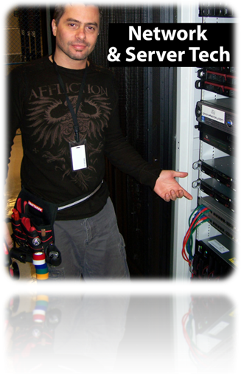
J. Burton and Associates (JBA) provides technology services for conventions and trade shows. I worked as a lead event technician on events throughout the United States, Europe and Asia. JBA provides private networks, large scale LAN and WIFI installations, VLANS, large scale DHCP services, computer / peripheral rentals, lab setup and management, speaker ready rooms, internet and support for Keynote and Track sessions,etc.

I worked all positions at JBA. A specialty of mine is to setup and manage the speaker ready room. Speaker Ready Room is the place a speaker arrives and works on his or her presentation. I help with whatever technical assistance they might need, including power point / keynote, pdf, graphic design, video, animations, etc. I also compile and distribute the presentations to the remote meeting rooms and act as a lead technician with supervisory responsibility. I managed onsite event crews up to 20 people (union and non union freelancers).

Program Event Producer 1992-1996
ROSIE PRESENTS San Francisco, CA

Rosie Presents was a promotion agency specializing in marketing / tradeshow events on a nationwide basis. My responsibilities included event planning, venue selection, sub-contracting, production meetings with clients, complex reporting, budget allocation, conflict resolution, technical direction and talent management. At Rosie Presents, my team was responsible for executing over 5,000 events in 4-years. Our clients included Remy Amerique, Bacardi, Lucky Strike, Marlborough, Diageo and many others.

Additional

San Francisco Territory Manager 1997
ACROPOLIS SYSTEMS, INC Milpitas, CA

Acropolis Systems Inc (ASI is now ”Bscaler” a SAAS firm) was a systems integrator focused on the fortune 100 market. ASI provided highly available (HA) systems to banks, oil companies, manufacturers, etc. HA systems provide over 99.999% uptime for mission critical applications. Additionally, we focused on Y2K compliance. I was the territory manager based at 1 Embarcadero. The named accounts in my book were responsible for 10M in sales during the year I was there. I setup meetings, identified opportunities, prepared detailed proposals, ROIs, case studies, networked with manufacturer reps and partners, and - MOST importantly - was able to get purchase orders from customers thus closing the deal. ASI had annual revenue of 36M in 1997.

Co-Founder / Investor 1997-2007
FRNK TECHNOLOGY GROUP, INC Scotts Valley, CA

I co-founded the FRNK Technology Group, a think-tank / development firm for web-based technologies. I designed systems utilizing state of the art software to offer turn key web applications as a service (or Software As A Service / SAAS). This was long before anyone else had even thought of it. I designed and produced a system for fully integrated and automated webcasting. This system is still in use today by Universities and Government agencies. My team also produced the first form of social networking just after 2000 implemented through adult community membership websites. We were pioneers in the field. While I was fairly active during the beginning years of this company, my involvement transitioned into a board position until the company finally sold in 2007 for 2.2 Million.

Owner 2008-2011
LIVE RECORDING AND SOUND Sacramento, CA

It took a year of planning and a year to fully build my fully equipped 128 Track Pro Tools 10 / 11 Mutlitrack tracking / mixing studio currently located in Grass Valley, CA which is used for clients multimedia and musical recording projects.
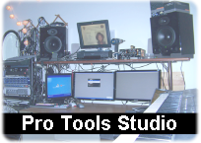
Studio Milestones;

- Engineered and Produced 5 albums
- Engineered and Produced mulitiple radio bumps
- Completed Pitch correction projects
- Completed Drum replacement projects
- Mixed Video soundtrack projects

Partial Equipment Rental List:

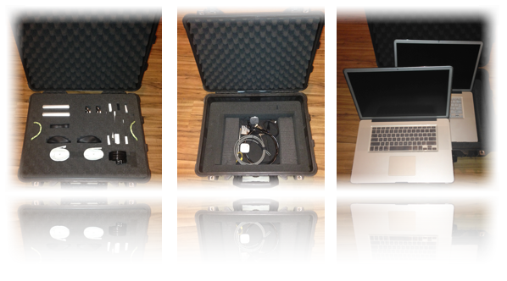

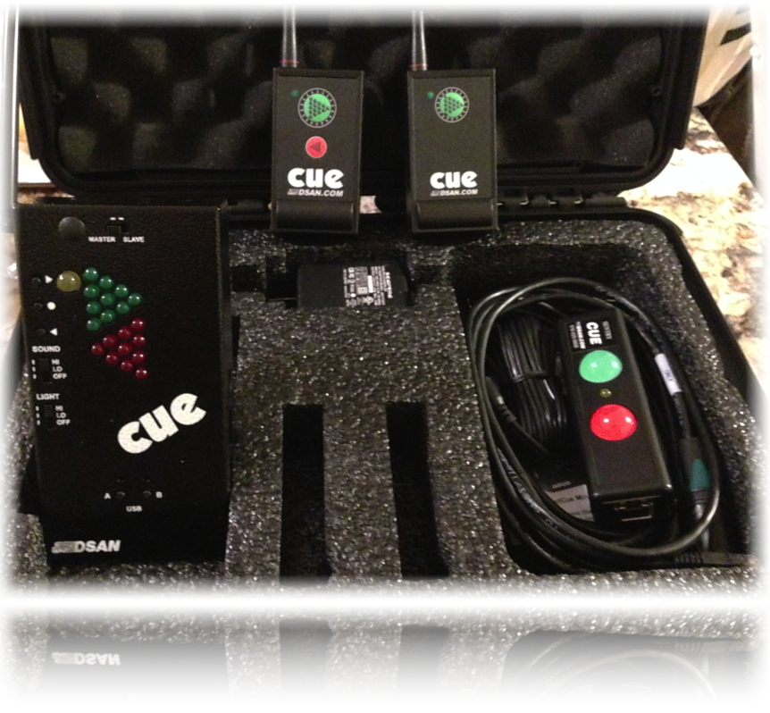
Pre Sonus – ACP88
AKG 414 G / Stereo pair
Mesa Boogie Triaxis
Rocktron Multi-valve
Alesis Quadraverb

Apple Dual Quad Core System with Multiple TBs of storage
DigiDesign 003 Interface
Digimax 8 Channel Interface
EL Labs Distressor
Neumann U87
Millenia TD1

Korg Triton Studio 88
Multiple Electric Guitar and Bass Instruments
Multiple Accoustic Guitar, Bass and Percussion Instruments

Graphics Computer Rental Flypack with Perfect Cue System

Fender Twin Reverb Amplifier(s)
Marshall 100W Tube Amp with 4x12 Cabinet
VOX Recording Amplifier with 12” speaker
Fender Acoustisonic Amplifier

Small PA System:
Mackie 32x8 Mixer with Metered Bridge
2ea 2x15x3x2x1 Mains
2ea 2x18 Subs
100’ 24 Channel Snake

References
You are more than welcome to contact my references to inquire about my work experience. I am happy to share any of their email addresses or phone numbers by request.

James Burton / J.Burton and Associates http://jburton.com
John Haworth / Riverview Systems Group http://riverview.com
Marc Kaplan / Riverview Systems Group http://riverview.com
Kevin Ricks / Hampton University, VA – Media Services Dept. http://www.hamptonu.edu
Gene Goodwin / WYCG – County of York, VA http://yorkcounty.gov
Jack Chin / City and County of San Francisco, CA – SFGOVTV http://sfgovtv.org
Mike Neeley / Projection, Moscone Center http://www.projection.com
Simon Tuck / Projection, Moscone Center http://www.projection.com
Mark Pace / CTO, Jolokia Networks http://www.jolokianetworks.com
David Carminito / Business Agent IATSE Local 16 http://local16.org
Steve Lutge / Business Agent IATSE Local 16 http://local16.org
Bill Jakab / Technical Director, Jack Morton Productions http://jackmorton.com
Carol Bailey / Producer, Big Show Productions http://bigshowpro.com
Casey Hiester / Producer, Invision http://iv.com
Suzanne McKaig / Producer, Group X http://groupx.com
Sean Von Seeger / Project Manager, Creative Technology US http://ctus.com
Alan Bagshaw / Technical Director, Bagshaw & Associates http://bagshaw.net
David Carminito / Assistant Business Agent IATSE Local 16 http://local16.org
Steve Lutge / Business Agent IATSE Local 16 http://local16.org

